Messages Application Design

Date | Version | Author | Modification
2006-9-25 | V0.1 | Alex Tang | Framework design
2006-9-26 | V0.1 | Alex Tang | Interface description  Architecture detail description
2006-10-8 | V0.1 | Alex Tang | Add layout pictures
2006-10-10 | V1.0 | Alex Tang | Layout Modify, Interface Add

Contents
1. Overview 3
1.1. Functions 3
1.2. Features 3
2. Layout Design 3
2.1. Widgets 3
2.2. Widgets Layouts 4
2.3. Five Message Modes Layout 5
3. Operation Flow 13
3.1. Message Sending Flow 13
3.2. Message Accepting Flow 13
3.3. Message Operations Flow 15
4. Datum Dictionary 16
4.1. SMS Datum 16
4.2. Email Datum 16
5. Interactions 17
5.1. Inner Interactions: Mode Switch 17
5.2. External Interactions: Modules Interaction 17
6. Interface 18
6.1. Inner Interface 18
6.2. External Interfaces. 20
7. Architectural Details 20
7.1. Messages Module Description 20
7.2. Messages Fields Defined 21
7.3. Messages Theme 21
7.4. Messages Operation 21

Overview
This article defines the Messages Application, an extensible application designed for the OpenMoko platform. Messages is an core application to create and store messages. It’s a naïve stylus-based application.

  - Functions
    - Read, new, reply, forward, delete messages (email and SMS)
    - Send messages to contacts in Contacts (email and SMS)
    - Insert pictures, drawings into email as attaches (email)
    - Add multiple email accounts (email)
    - Specify custom folder
    - Store, move messages to custom folder

  - Features
    - Auto-complete contact information (SMS)
    - When a new message is created it is automatically saved into the Drafts folder
    - Abstract date and time (can add to calendar and Todo), address, phone number (can add to Contacts), email, web URLs from message body.

Layout Design
  - Widgets
Required Widgets are as follows：
    - Menubar: Container for application and filter menu.
    - Application Menu: Display messages in custom folder, rename folder, open account dialog, get help.
    - Filter Menu: Filter messages by folder.
    - Navigation List : Show messages subjects, status, content.
    - Toolbar : Container for search and action buttons.
    - Search: Search in messages.
    - Action Button: Click to emit an event.
    - Detailed List: Switch different message modes
    - Auto-complete: Auto complete phone number or email address
    - Message Body: Display message content, retrieve phone number, email, address, etc.
    - Footer: Display message number in current folder
    - Accounts Dialog: Add email account

  - Widgets Layouts
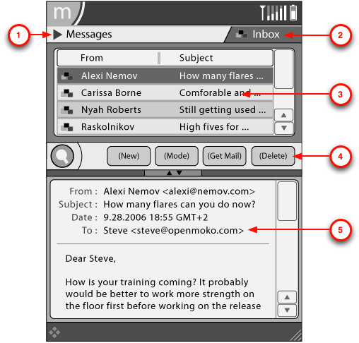
Figure 2-1 Messages Layout
Layout ( top to bottom) are as follows
    - Menu bar contains:
      - Application Menu ① contains: Message Membership (click to enter 【Message Membership Mode】, Folder Rename, Accounts (click to activate Account Dialog), Help
      - Filter Menu ② contains: Inbox, Outbox, Drafts, Sent, <Folder>, Search Results
    - Navigation List ③ has 3 columns (left to right) : message status icon, recipient message, email subjects or portion of body of SMS messages
    - Toolbar ④ (left to right) contains：
      - Search
      - Action Buttons (left to right) contains: New, Mode Read, Mode Reply, Mode Forward, Get Messages, Delete
    - Details Area ⑤ (depends on modes) contains: Auto-complete, Message Preview
    - Footer

  - Five Message Modes Layout
Messages has five modes layouts as follows：
    - Mode Read (Email, SMS)
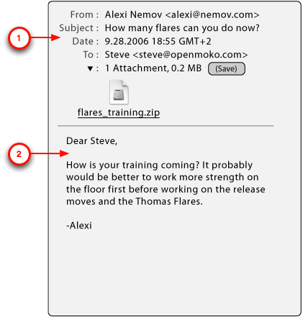
Figure 2-2 Email Read Mode Layout (Full)

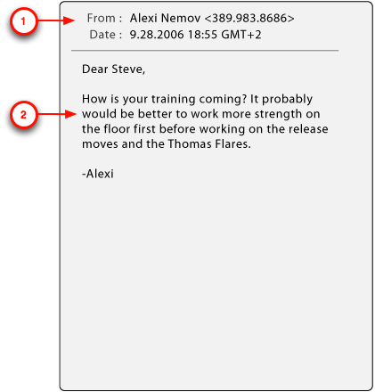
Figure 2-3 SMS Read Mode Layout

    - Mode New (Email, SMS)
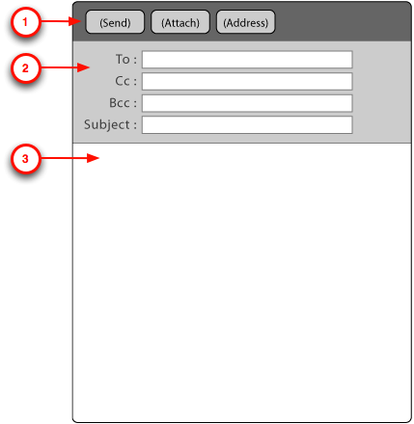
Figure 2-4 Email New Mode Layout

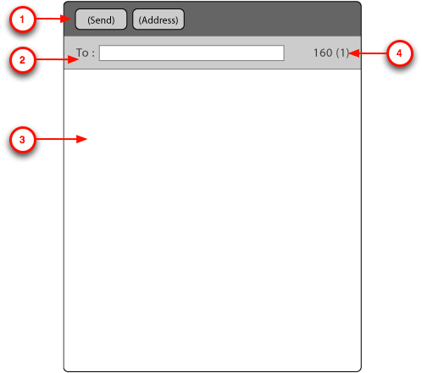
Figure 2-5 SMS New Mode Layout

    - Mode Reply (Email)
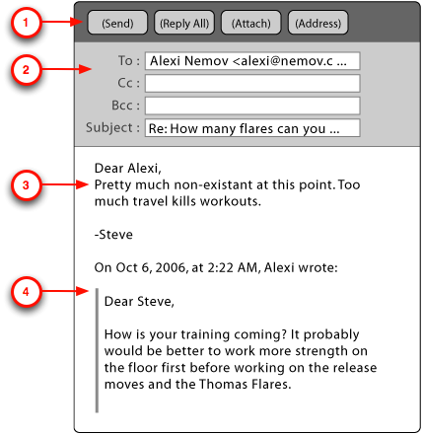
Figure 2-6 Email Reply Mode Layout

    - Mode Forward (Email, SMS)
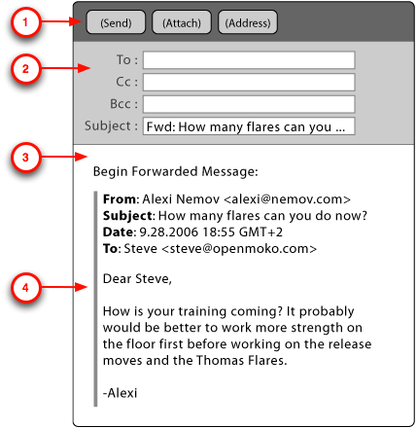
Figure 2-7 Email Forward Mode Layout

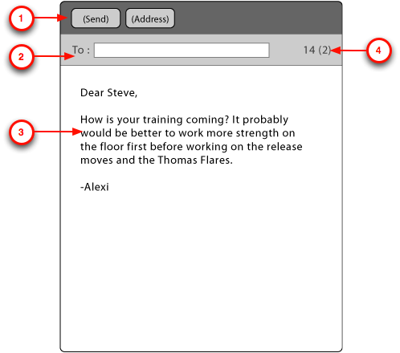
Figure 2-8 SMS Forward Mode Layout

    - Message Membership Mode
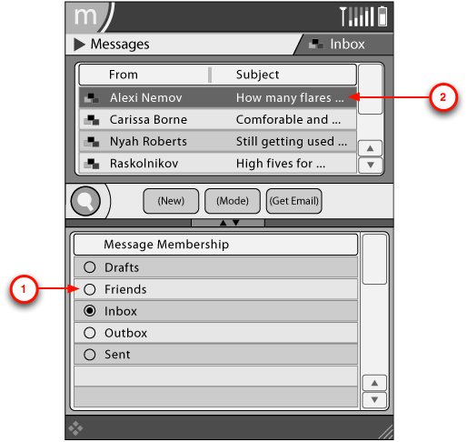
Figure 2-9 Message Membership Layout

Operation Flow
  - Message Sending Flow
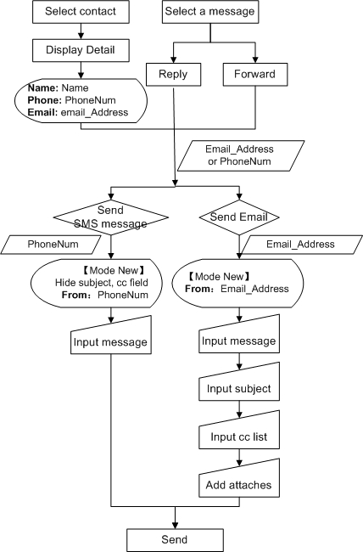
Figure 3-1 Message Sending Flow

  - Message Accepting Flow
    - SMS Messages Accepting
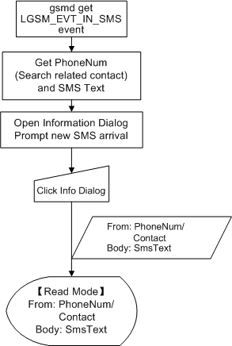
Figure 3-2 SMS Message Accepting Flow

    - Email Accepting
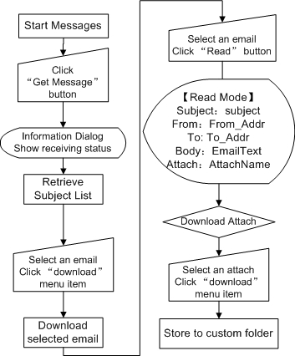
Figure 3-310 Email Accepting Flow

  - Message Operations Flow
    - Read
      - Select folder in filter menu
      - Select message in navigation list to read
      - Click “Read” button
      - Read in Details Area【Mode Read】

    - Reply
      - Select folder in filter menu
      - Select message in navigation list to reply
      - Click “Reply” button
      - Depending on message type sms or Email, get into “Message Sending Flow” 【Mode Reply】, phone number or email address is transmitted from selected message body

    - Forward
      - Select folder in filter menu
      - Select message in navigation list to forward
      - Click “Forward” button
      - Depending on message type SMS or Email, get into “Message Sending Flow” 【Mode Forward】, phone number or email address is transmitted from selected message body

    - Move (Optional)
      - Select folder in filter menu
      - Select message in navigation list to move
      - Single click menu item “move to folder xx”

Datum Dictionary
  - SMS Datum
Item | Type | Description | Constrains
PhoneNum | gchar * | SMS message receiver number | All should be numbers
SmsText | gchar * | SMS message body | If message body contains more than 140 ASCII characters or more than 70 Chinese characters, this message will be split into several messages to send.
Index | gint | SMS index | If messages contains more characters than predefined, index will be use to indicate current message index
Table 4-1 SMS Datum Table
  - Email Datum
Item | Type | Description | Constrains
To_Addr | gchar * | Email destination address | Email address, separates by ‘,’
Subject | gchar * | Email title | None
From_Addr | gchar * | From email address | Email address, separates by ‘,’
CC_Addr | gchar * | CC list email address | Email address, separates by ‘,’
EmailText | gchar * | Email body | None
Attach | gchar * | Attaches (files, path) | None
Table 4-2 Email Datum Table

Interactions
  - Inner Interactions: Mode Switch
Messages modes switch as follow figure:
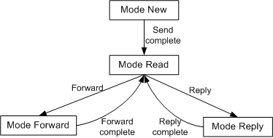
Figure 5-1 Mode Switch Table

  - External Interactions: Modules Interaction
    - Related external modules
      - Contacts
      - Dialer
      - Footer
      - Search

    - Interactions between modules
Modules interact as follow figure:
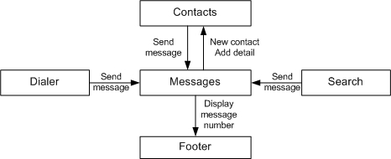
Figure 5-2 Modules Interaction

Interface
  - Inner Interface
Functional:
New message
void new_msg_cb ( )

New folder
gint new_folder_cb ( gchar *fname )

Read a message
void read_msg_cb ( GtkWidget *nlist )

Reply a message
void reply_msg_cb ( GtkWidgetGtkWidget *mbody, GtkWidget *toEntry )

Forward a message
void forward_msg_cb (GtkWidgetGtkWidget *mbody, GtkWidget *toEntry )

Receive message (Email)
gint get_msg_cb ( )

Menu callbacks:
Application Menu cbs:
Message Membership Mode.
viod ap_mm_cb ( gchar *fname )

Rename a folder.
gint ap_frename_cb (gchar *fname, gchar *newname )

Add email account.
void ap_account_cb ( )

Get help.
void ap_help_cb ( )

Filter Menu cbs:
Browse inbox.
gint fm_inbox_cb ( GtkWidget *nlist )

Browse outbox.
gint fm_outbox_cb ( GtkWidget *nlist )

Browse drafts.
gint fm_drafts_cb ( GtkWidget *nlist )

Browse sent.
gint fm_sent_cb ( GtkWidget *nlist )

Browse a custom folder.
gint fm_folder_cb ( GtkWidget *nlist, gchar *fname )

Browse search results
gint fm_searchresult_cb (GtkWidget *nlist )

Search
Search in messages.
gint search_msg_cb ( gchar *skey )

Navagation list cbs:
Select a row in Navagation List.
void nl_rowsel_cb ( GtkWidget *nlist )

Message body:
Get date and time.
gchar *abs_datetime_cb ( GtkWidget *mbody )

Get email address.
gchar *abs_email_cb ( GtkWidget *mbody )

Get address.
gchar *abs_address_cb ( GtkWidget *mbody )

Get phone number.
gchar *abs_phonenum_cb ( GtkWidget *mbody )

Detail Area
Attach (Email) button
gint da_add_attach_cb ( GtkWidget * at_entry )

Address (Email, SMS) button
gint da_address_cb ( GtkWidget * nlist )

Message Membership Mode Radio button
gint da_radiobtn_cb (GtkWidget * nlist )

  - External Interfaces.
Footer:
Display message number on footer.
gint ft_disp_msgnum ( )

Contacts:
Add a new contact.
gint ct_new ( gchar *name, gchar *phonenum, … )

Add details.
gint ct_add_detail ( gchar *name, gchar *detail )

Messages:
Send an SMS message.
gint send_sms_msg_cb ( gchar *phonenum, gchar *smstext )

Send an email message.
gint send_email_msg_cb ( gchar *subject, gchar *toAddr, gchar *ccAddr,
gchar *fromAddr, gchar *emailtext, gchar *attach )

libmokocore (dbus):
Send messages to app x
gint send_dmsg (gchar *appx, gchar *message, gchar *attr1, gchar *attr2….)

Send messages to all
gint broadcast_dmsg ( gchar *message, gchar *attr1, gchar *attr2…. )

Architectural Details
  - Messages Module Description
    - Messages is an naïve stylus-based application. It’s in the application layer of OpenMoko framework. It’s position is as following figure:
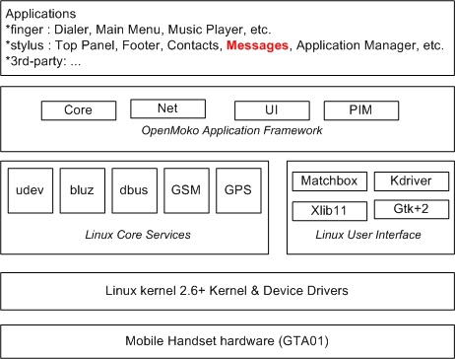
Figure 7-111 Messages Module Discription

    - Messages GUI is programmed with libmokoui (Gtk+). It utilizes libmokonet (libgsm) to deal with SMS messages and libsmtp to send emails. Messages will communicates with other module by libmokocore (dbus).

  - Messages Fields Defined
    - Valid messages fields definition can be found in PIM document.

  - Messages Theme
    - Messages theming issues can be found in OpenMoko Theme and Pereference documents.

  - Messages Operation
    - Messages Operations can be found in Stylus-Based Application document.

